Delete Food Item

Document Information

|  |  |
| --- | --- |
| **Document Title** | Title of use case – Verb Noun phrasing is almost always the most appropriate! |
| **Document Owner** |  |
| **Version** |  |
| **Status** |  |
| **Date** |  |

1. Brief Description

This use case allows the School Administrator to delete a food item from the system.

1. Actors

* School Administrator

1. Trigger

The school administrator wants to delete a food items.

1. Pre-Conditions

* The school administrator must be logged into the system.
* The food item to be deleted must exist in the system.

1. Post-Conditions

* The selected food item is deleted from the system.
* The system updates the food list.

1. Basic Flow
2. The School Administrator selects the "Food Item" menu.
3. The system displays a list of existing food items.
4. The School Administrator selects the food item to be deleted.
5. The School Administrator clicks on the "Delete" button.
6. The system displays a confirmation message.
7. The School Administrator confirms the deletion by clicks on the “Confirm” button.
8. The system deletes the selected food item.
9. The system removes the deleted food item from the food list.
10. The system returns the School Administrator to the food list.
11. Alternate Flows

• 2a: The school administrator can search for a specific food item by entering the name or a part of the name in the search box. Then continue step 3.

1. Exception Flows

* 2b: If there are no food items available, the system displays a message "No food items found."
* 5a: If the School Administrator cancels the deletion by clicks on “Cancel” button, the system returns the School Administrator to the food list.
* ~~6a: If the selected food item has already been ordered and the orders are confirmed, the system displays an error message and cancels the deletion. The School Administrator is returned to the food list. (Step 2).~~
* ~~7a: If the system encounters an error while saving the changes, the system displays an error message and prompts the school administrator to try again.~~

1. Business Rules

* Only the School Administrator can delete food items.
* ~~The School Administrator cannot delete a food item that has already been ordered and the orders are confirmed.~~

1. Non-Functional Requirements

* The system must update the food list immediately after the deletion is confirmed (1s).
* The system must provide clear error messages in case of errors or exceptions.

1. Supplemental Requirements
2. Visual Model

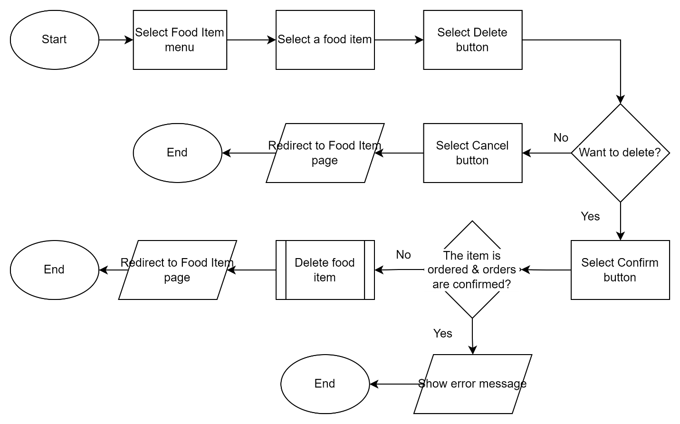

Revision History

|  |  |  |  |  |
| --- | --- | --- | --- | --- |
| V. | Date | Author | Description | Status |
| 1 | 24/04/2023 | Hoang Anh | Create document |  |
| 1.1 | 25/04/2023 | Hoang Anh | Remove E.6a because a food item can be deleted even being orderd. |  |
| 1.1 | 01/05/2023 | Hoang Anh | Remove E.7a because cannot test the case. |  |